OWN’S

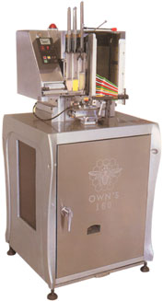

OWN’S AUTOMATIC TOOTHBRUSH
MANUFACTURING MACHINES

OUROWN’S MACHINERY CAN RESOLVE
THE MOST COMMON TROUBLES.

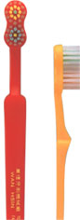
OWN’S-160C
Automatic 3-Colour
Toothbrush Tufting Trimming & End-rounding Machine

How Many Toothbrushes
Do You Know Will Be Used Per
Year In The Globe ?

Toothbrush is one of daily necessities in our life. Everyone
Will use 4 t/brushes on average per year, still more the
disposable t/brushes for hotel use. So how many tooth-
brushes will be used per year in the globe ?

WAN HSIN TOOTHBRUSH MACHINERY MANUFACTURING CO., LTD.
No.422 Chuncheng N. Rd., Sanchung City, Taipei Hsien, Taiwan
Tel:(02)2982-1101 (Red) Fax:886-22983-7666

3 | ------------------------- | COMPANY PROFILE
4 | ------------------------- | OWN’S-10 HANDLE MOULD  FLAT BRASS WIRE  OWN’S-40 MATERIAL BRISTLE BLADE
5 | ------------------------- | OWN’S-42 AUTOMATIC MATERIAL BRISTLE  CUTTER & WATER SEPARATOR MACHINE
6 | ------------------------- | OWN’S-100 AUTOMATIC 2-COLOUR  TOOTHBRUSH TUFTING MACHINE
7 | ------------------------- | OWN’S-160 AUTOMATIC 2-COLOUR  TOOTHBRUSH TUFTING TRIMMING & END-ROUNDING MACHINE
8 | ------------------------- | OWN’S-60(FLAT & STRAIGHT SHAPE)  OWN’S-61(WAVED, TOOTHED OR SEGMENTAL SHAPES, ETC. )  AUTOMATIC BRISTLE TRIMMING & END-ROUNDING MACHINE
9 | ------------------------- | OWN’S-70(FLAT & STRAIGHT SHAPE)  OWN’S-71(WAVED, TOOTHED OR SEGMENTAL SHAPES, ETC. )  SEMI-AUTO BRISTLE TRIMMING MACHINE  OWN’S-75 AUTOMATIC AIR PRESSURING  STRAIGHT CUTTING MACHINE
10 | ------------------------- | FLOW CHART OF TOOTHBRUSH MAKING
11 | ------------------------- | PROPOSAL OF TOOTHBRUSH MAKING PLANT  PLAN LAYOUT (10MX25M)
11 |  | RAM MATERIAL REQUIRED
12 | ------------------------- | MACHINERY & EQUIPMENTS REQUIRED

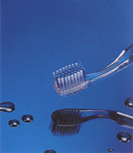
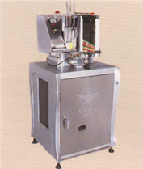
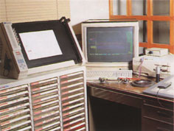
A view at the computer drawing

COMPANY PROFILE

WAN HSIN TOOTHBRUSH MACHINERY MANUFACTURING
CO., LTD. was established in 1977 and has adhered to the
business aim in "Permanent Business Running" and "Non-
seeking Short-sighted Advantage". The founder of the
company, Mr. Wen-Chi Wong, the age of 40s, had been
working at the most famous toothbrush factory in Taiwan
since 13 years old. After the long period for working hard
& learning diligently there, he not simply possesses tremen-
dously rich experience in the practically technical operation
and also has a good knowledge of the construction of the
whole plant machinery & equipments for toothbrush manu-
facturing. In addition, he himself has already gone through
the evolution of the production of toothbrush making equip-
ments for 30 years in Taiwan.
In truth, we are a professional plant with the rich experience
& good credit to supply the whole plant machinery & equip-
ments for toothbrush making, by which our machines have
been supplied abundantly to 80% of the local toothbrush
manufacturers in Taiwan, and also exported to a lot of
countries worldwide, such as Saudi Arabia, Iran, Pakistan,
Bangladesh, India, Nepal, Sudan, Egypt, Sri Lanka, Costa
Rica, Mexcio. Malaysia, Philippines. Indonesia, Thailand,
Hongkong and Mainland China...etc.-After many years
constant research & development, our machines have been
made a great deal of unprecedented advance in the
improvement & originality by the use of Hi-tech tech-
niques, equipments & material. Besides, we have stuck
fast to the selling principle of "high quality & low price",
So, compared with the Japanese machinery, the price of
our machinery is quite low but quality is never devalued, by
which no wonder that our machines have won loads of
recognition, praise & reputation both in domestic & over-
seas markets.
In recent years, our plant has constantly made a great deal
of investment & energy in the new machine's invention &
research, through which our OWN'S brand machines not
only have possessed the unprecedented breakthrough &
originality, but also we are so proud of ourselves-made
high quality products with the international standard accept-
ed & used generally.

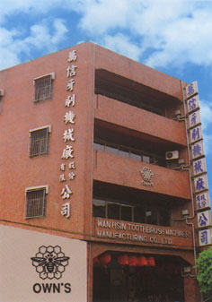
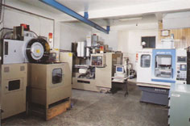
A view at the CNC production
CNC製造現場

At present, our company has already bought the land with 4000 m² in square located in the technological area for the pofessional machinery manufacturing in Kuan Shi of Hsinchu City, which is ready for our new plant establishing. Besides, in 3~5 years from now, we are planning to make a great deal of investment amounting 15% of annual turnover in development and innovation, through which we are convinced the quality of machinery for toothbrush making will be lifted further. At last, we will continue our efforts so that our OWN'S machines can become the popular & noticeable brand around the world in the future.

OWN’S-10

HANDLE MOULD
Features
The mould is made under the advanced CMC production
system, by which the toothbrush holes will be quite accu-
rate & precise during tufting.
Specifications
Material…….…………………………Sweden Assab Stee718
(for the main part)
Cavity……..……………………………..……Eight or Sixteen
Dimention…………..……………………………50×22×28cm
Packing dimention……………………….......…..60×35×32cm
N.W…………………….............…………….…............180kgs
G.W…………….......................………………................190kgs

FLAT BRASS WIRE
Specifications
Thickness………….………………….…………0.23~0.25mm
Width……..……………………………….………..1.1~1.3mm
Packing dimention
(1wooden case for 100kgs)……………………..55×40×30cm
N.W………………….…………………………………100kgs
G.W……………….…………………………………….110kgs
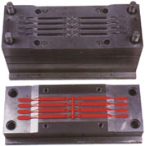

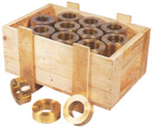

OWN’S-40

MATERIAL BRISTLE BLADE
Features
▼ Both knife & blade inside are made of special steel under the heating treatment.
▼ Cutting edge with the grind-resistance is quite hard &sharp.
Specifications
Capacity…….…………………………………………………………….…..60kgs/hr.
Dimention………….……………………………….……………..…..130×55×105cm
Packing dimention…………………….………….…..145×70×70cm (Legs separated)
N.W…………………………………………...………..………………………..40kgs
G.W………….………………………………..…………….…………………..100kgs

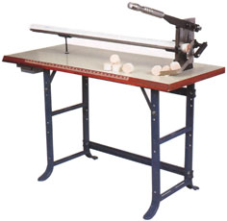

OWN’S-42

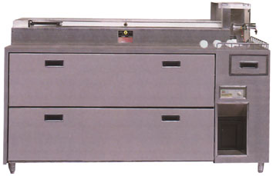

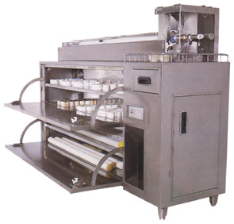
AUTOMATIC MATERIAL BRISTLE CUTTER & WATER SEPARATOR MACHINE
Features
▼ Elegant appearance made of stainless steel meets abso-
lutely the hygienic production enviroment.
▼ Automatic material bristle feeding, air-pressure cutting,
transparent & safty protection cover and special sharp cutting edge.
▼ 4- cabinets for storing nylon (material bristle), in which the
dehumidifier is installed, which can get rid of the moisture
inside nylon into the water storage tank to stay nylon
perfect under the proper drying reading.
▼ Nylon without moisture can have each tuft of brush insert-
ed averagely on each hole to keep the tufting process
smooth & precise, which is a requisite for making the top
quality toothbrushes.

Specifications
Capacity…………………….…………………120kgs/hr. Max. length of cutting nylon.
…………………………………………………….…….50mm
Capacity of water storage tank………….……….………..2.4L
Motor…….………………………………………….…..1/2HP
Voltage…….…………………..….AC 200-240V 50HZ~60HZ
singlephase
Kilowatts………….……………………………………..400W
Air pressure………….………………..……….…...6-8kgs/cm²
Air fiow………….………………………..…15L/min/(1/2HP)
Dimention………….………………………….180×50×120cm
Packing dimention………….…………………195×65×145cm
N.W…………………………………………...………..160kgs
G.W…………………………………………....……….265kgs

OWN’S-100

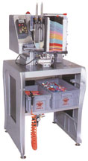
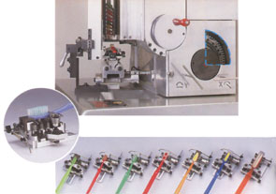
A set of adjustable
cam, clamp & han-
dle chute.

The universally adjustable clamps for different shapes of toothbrushes.

AUTOMATIC 2-COLOUR TOOTHBRUSH TUFTING MACHINE

Features
▼ The components of OWN 'S-100 are 30% fewer than those of the old-mode OWN'S-51, but its productive speed is enhanced up to 4-0 % .
▼ 80 % of OWN'S-100 is made of the special aluminium alloy for the navigational industry under the hardening treatment. Also the appearance through CAD computer drawing design is produced by the combination of the segmental frame of two pieces of alloy and the solid streamlined shape with the different stratum of the concave & convex construction, which will exhibit greatly the perfect visual effect of physique and beauty. And the cover packing design will reduce the noise.
▼ The motion of OWN'S-100 is quite smooth & accurate bec-
ause of the new-fashioned X & Y slide rest having the precise shaft bearing of the linear motion.
▼ Originatively universal clamp, cam & handle chute can suit
the production of any various shapes of toothbrushes out of the characteristic of their repeated adjustment, which will save much time & capital for the new clamp, cam & handle chute making to match each shape's change.
▼ Latest-designed protective installation to keep needles from bumping, which will make brush tufted under the fixed setting reading of air pressure. The protective installation will open automatically to stop tufting if air pressure is over the setting reading, which will prevent needles from breaking & cracking.
▼ During tufting, some special situations, the mechanical break-
down or the insufficient suply of nylon, handles & flat brass wire, will be informed through the indicating light & the alarm sound working.
▼ The machine itself has no the computer installation & PC co-
ntroller, so there is no any trouble in maintenance & repair.
▼ The latest-created mode, OWN'S-lOOC, specializes in 3colo-
ur toothbrush making.
Specifications
Capacity………………………………T/brush holes tufted/1~66 holes
Output………………………………...…………250-290 tufts/per min
Shape.......Any various types of irregular arrangement of T/brush holes
Motor…….………………………………………………………1/6HP
Voltage……..………….…….…220V-240V 50HZ~60HZ single phase
Kilowatts………….……………………………………………..220W
Air pressure………….…………….……………………….5-7kgs/cm²
Air fiow…………………………………………3L/min/10pcs(1/8HP)
Dimention………………………………………………70×70×150cm
Packing dimention………….……..……………………85×85×165cm
N.W…………………………………………………………….110kgs
G.W………….………………………………………………….195kgs

OWN’S-160

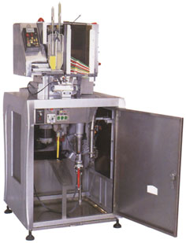
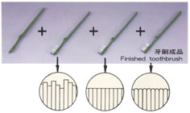
=

AUTOMATIC 2-COLOUR
TOOTHBRUSH TUFTING TRIMMING & END-ROUNDING MACHINE

▼ A complete rapid production.
▼ Quality testing straight away.
▼ NO-waiting operation of semi-products supplying.
▼ Big reduction of defective products.

Features
- The machine is the first one to be exhibited in Asia, which incorporated tufting, trimming and end-rounding into one entity, by which the toothbrush tufting, trimming & end-rounding will be finalized simultane-
ously by the fully auto-matic operation. So 50 % of manpower will be saved.
▼ The floor square required will be smaller because of the fact that two machines (OWN'S-IOO+OWN'3-60) are incorporated into one entity.
- Trimming & end-rounding facilities are installed
privately in the seal-cabinet located in the lower part of the machine, in which there is a special container for collecting nylon crumbs which will stay clean around the machine.
▼ The machine has two parts, upper & lower, the upper part is fully same with OWN'S-100 just for tufting. (It is optional for 2 colour or 3 colour.) The lower part is for trimming & end-rounding. [It is optional for flat type (just like OWN'S-60) or special type-waved, toothed or segmental types (just like OWN'S-61)].
- One single creative diamond-polishing wheel replaces 8 ones with the different size, which have the brush rounded much more better than before.
- Compared with the European machines with the same
mode, the price of OWN'S-160 is quite low.

Specifications
Capacity……………………………..……..T/brush holes tufted/1~66 holes
Output………………………………...………………250-290 tufts/per min
Shape……....Any various types of irregular arrangement of T/brush holes
Motor……..………………………………1/10HP×1，1/6HP×1，1/2HP×2
Voltage…………..……………………………………….220V single phase
Kilowatts…………………………………………………………….1100W
Air pressure…………..………………………………………….5-7kgs/cm²
Air fiow………….………………………………….15L/min/10pcs(1/2HP)
Dimention……………………………………………………70×70×150cm
Packing dimention…………...………………………………85×85×165cm
N.W. ..……….……………………………………………………….200kgs
G.W.………………………………………………………………….285kgs

OWN’S -60 (FLAT & STRAIGHT SHAPE) -61(WAVED, TOOTHED OR SEGMENTAL SHAPES, ETC.)

AUTOMATIC BRISTLE TRIMMING & END-ROUNDING MACHINE

Features
▼ 30 universally adjustable clamps, each one of which is
suitable for any various types of toothbrush heads.
▼ 8 latest-designed diamond-polishing wheels can trim &
round the end of brush into the half-ball shape with the smooth surface.
▼ The blade inside is made of special steel with the strong hardness & endurance. The sharp cutting edge can have irregular brushes cut neatly.
▼ The appearance with the stainless steel not simply meets the hygienic standard of producing enviroment and also decrease the surface damage from outside friction & bump and keep perfect.

Specifications/規格說明
Capacity………….……………………….……..3600pcs/hr.
Max. length of handle……………….………………210mm
Max. width of head……………….…………………..14mm
Max. thickness of head………………………………3-7mm
Length of brush………….………………………….5-20mm
Number of adjustable clamp……………….………….30pcs
Motor………..………………………….3/4HP×2，1/8HP×1
Voltage…………..……………………….220V single phase
Kilowatts………………….…………………………1200W
Dimention…………………………………..100×45×100cm
Packing dimention…………...……………..115×60×120cm
N.W. ………...……………………………………….165kgs
G.W. ………...……………………………………….235kgs
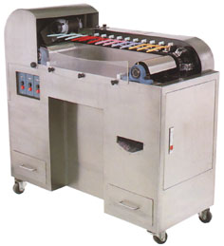

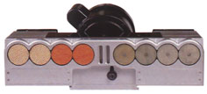

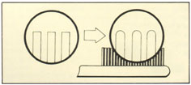

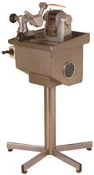
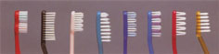
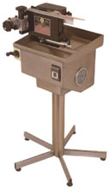
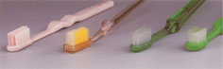

Features
▼ The machine specializes in having brush trimmed into concave &. convex shapes with any kind of long-short shank.
▼ The brush cutting operation can be done at one time. (The steps are to trim brush inside first and then trim brush outside), which will save the trouble for 4 workers operating
▼ The brush trimming is quite stable & precise because of the air-pressure installation for the speed adjustment.

Specifications
Capacity…………………………………………………1500pcs/hr.
Air pressure………………………………………………5-7kg/cm²
Motor…………………………………………………………1/3HP
Voltage………….……………………………….220V single phase
Kilowatts……………………………………………………..300W
Dimention…………..……………………………….60×60×100cm
Packing dimention…………..………………………73×73×120cm
N.W. ………..………………………………………………...45kgs
G.W. ………...……………………………………………….100kgs

Features
▼ Stainless steel appearance, seal-up blade design, which meet the hygienic production enviroment.
▼ During the manual trimming, there is no need to hold tightly because of the handle automatic fixing installation.
▼ The wear-resistant blade under special treatment can have bristle trimmed regularly & neatly.

Specifications
Capacity………….………………………………..1200-1800pcs/hr.
Thickness of head……………………………………………3-7mm
Max. width of head……………….…………………………..14mm
Motor…….……………………………………………………1/3HP
Voltage…………..……………………………….220V single phase
Kilowatts………….…………………………………………..250W
Dimention……………………………………………60×60×100cm
Packing dimention……………………………………73×73×120cm
N.W. ………...………………………………………………...45kgs
G.W. …………...…………………………………………….100kgs
OWN’S-70
(FLAT & STRAIGHT SHAPE1)
OWN’S-71
(WAVED, TOOTHED OR SEGMENT-
AL SHAPES, ETC.1)
SEMI-AUTO BRISTLE TRIMMING MACHINE1
OWN’S-75
AUTOMATIC AIR PRESSURING STRAIGHT CUTTING MACHINE

OWN'S Automatic Toothbrush Manufacturing Machines
Plastic Process Machine


HORIZNTAL PLASTIC INJECTION MOLDING MACHINE
VERTICAL PLASTIC INJECTION MOLDING MACHINE

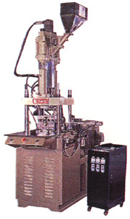
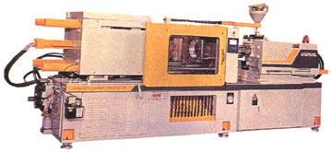
COLOR MIXING M-
ACHINE OF PLAST-
IC MATERIAL

Explanation:
It is used to inject 8~12pcs (depends on what kind of toothbrush, usually it's 8 cavities per mold) of single color toothbrush handles per 30~40 second per shot.

DESCRIPTION | UNIT | HORIZNTAL TYPE | VERTICAL TYPE
INJECTION |  | 125T | 55T
Screw Diameter | mm | 45 | 32
Theoretical in jection Volume | cm³ | 389 | 90
In jection Pressure | kg/cm² | 1839 | 1030
In jection Rate | cm³/sec | 120 | 104
Shot Weight | grams | 326 | 82
CLAMPING UNIT
Distance Between Tie Bars(H×V) | mm | 420×420 | 400×250
Mold Platen | mm | 620×620 | 580×430
Mold Height | mm | 100-450 | 150-280
Die Opening Stroke | mm | 400 | 200
Diameter of Centering Ring | mm | 120 | 90
Ejector Stroke | mm | 110 | 45/95
Ciamping Force | tons | 125 | 45
GENERAL DATA
Number of Heating Zones | zones | 4 | 1+2
Heating Capacity | kw | 7.6 | 3.5
Pump Driving Motor | hp | 25 | 7.5
Machine Size(L×W×H) | m | 5.4×1.4×1.5 | 2.6×1.2×3.1
Net Weight | kgs | 4000 | 2600
Packing Size (L×W×H) | m | 5.6×1.8×2.2 | 2.7×1.3×2.3
Shipping Weight | kgs | 4500 | 2900

Explanation:
It is used to inject and stuff two-color toothbrush handles with stopping slide soft plastic.It can inject and stuff 8pcs of toothbrush handles per about 30~40secounds per shot.

OWN'S Automatic Toothbrush Manufacturing Machines
Plastic Process Machine

VERTICAL COLOR MIXING MACHINE OF PLASTIC MATERIAL直立式塑膠原料色混合機

POWER (HP) | CAPACITY  (kg)
3 | 50
WEIGHT  (kg) | MACHINE  SIZE  (L×W×H)  (mm)
120 | 750×  750×  1250

Features：
- This Mixer is applicable mixing of the color plastic material in granular form, fodder, foods and other material.
- The mixing bucket is specially designed and made of 304 stainless steel and the inside of the bucket is very smooth.
- This Mixer is provided with safety device to protect the operators.
- The mixing time can be set from 0-12 minutes for automatic stop.
- Safety and time saving.

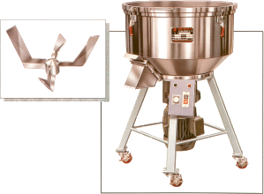

Machine's design & specifications subject to change without notice.
POWER(HP) | THROAT SIZE(mm) | FIXED BLADE | ROTARY BLADE | CAPACITY  (kg/hr) | WEIGHT  (kg) | MACHINE SIZE  (L×W×H)(mm)
2 | 200×250 | 2 | 12 | 40-60 | 150 | 750×450×1100

PLASTIC WASTE CRUSHER MACHINE
Explanation:
It is used to crush the waste material of the connection of 8pcs toothbrush handles after injection.Crush and use material to mix with new material to inject toothbrush handles.

Crushing capacity:50kgs of waste plastic material.

OWN'S Automatic Toothbrush Manufacturing Machines
牙刷專業機械整廠設備

OWN'S Automatic Toothbrush Manufacturing Machines
Package Machine

FULLY AUTOMATIC VACUUM FORMING MACHINE

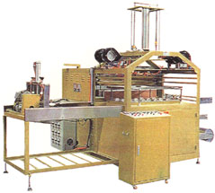
Application：It can be used to mold different type of transparent cover and food
container.
Features:1.This machine has and down molds capable of forming PVC.PET.PP and PS
cover,containers etc.
2.Equipped with automatic plastic roll feeding device for manpower saving.
3.Divided section Heater temperature adjustment controlled by S.S.R can
get the most even,stable and ideal temperature.
4.Equipped with fan and water cooling systems.

Power | 3P220/415V 50/60HZ
Forming Area(mm) | 570×1,000
(Round/min)Forming Efficiency | 2-4
Heater | 24.2KW
Vacuum Pump | 5HP
Mechanical Dimensions(L×W×H)(mm) | 3,200×2,150×2,600
Case Dimensions(L×W×H)(mm) | 3,400×2,300×2,090
G.W. N.W. | 3,500Kgs. 3,000Kgs.

HYDRIALIC TYPE HIGH FREQUENCY WELDING & CUTTING MACHINE MACHINE

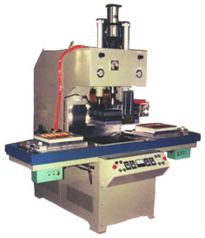
Application：For PVC and PVC toothbrush packing or PVC and Paper toothbrush packing

Features:The machine is designed for simultaneous welding and cutting 6 brushes
when processed

Power | 3P220/415V 50/60HZ
Input Power | 25KVA
H.F.Out-put Power | 15KW
Operating Frequency | 27.12MHZ
Packing Area | 350x450m/m
Packing Capacity | 3~4time/min
Mechanical Dimensions(L×W×H)(mm) | 2100×1950×2000
Case Dimensions(L×W×H)(mm) | 2150×1000×2170×1 2300×900×700×1
N.W. | 1050Kgs
G.W. | 1200Kgs

OWN'S Automatic Toothbrush Manufacturing Machines
Package Machine

HIGH FREQUENCY WAVE PLASTIC WELDING MACHINE
Power | 3P 220/415V 50/60HZ
Max. Power Requlrement | 15KVA
Max. Output | 8KW
Operating Frequency | 27.12MHZ
Packing Capacity | 3-4Time/Min
Packing Area | 350×450 m/m
Machine Size (LxWxH)m/m | 2600×1700×1900
Case Size (LxWxH)m/m | 1900×1000×2100×1 2800×800×500×1
N.W.  G.W. | 850KGS  1000KGS

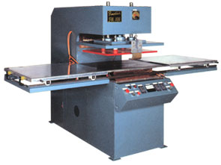
Application：For PVC and PVC toothbrush packing.
Features:The machine is designed for simultaneous welding and breaking 6 PVC and PVC toothbrush when processed or welding PVC and Paper toothbrush packing.

FLOW CHART OF TOOTHBRUSH MAKING

Fiat
Brass Wire

OWN'S-60
OWN'S-61
Auto Bristle
Trimming & Endrounding
Machine

OWN’S-10
Handle mould

Plastic
Iniection
Moulding
Machine

OWN'S-30
Air-pressure
Hot Stamping
Machine

OWN'S-100
Auto Bristle
2-Colour
Toothbrush
Tufting
Machine

Semi-
Products

OWN'S-70
OWN'S-71
Semi-Auto
Bristle
Trimming
Machine

OWN’S-40
Material Bristle
B1ade

NYLON

OWN'S-42
Automatic Material Bristle Cutter
& Water Separator Machine

Paper Box
Packing

Plastic Hard Container
Packing

Quality
Testing

Toothbrushes

Packaging
Machine

Finished
Products

High Frequency
Blister Packing

Blister Card Packing

PROPOSAL OF TOOTHBRUSH MAKING PLANT

Example:X area has a population of 10,000,000, in which everyone must use 4 toothbrushes per year , and three toothbrush making plants have been found here. So what proposal will the forth new-establishing toothbrush making plant need to have if it expects 10% of annual output amongest 40,000,000 pcs of T/brushes —
40,000,000pcs × 10% ÷250 days/year= 16,000 pcs?(42 holes8 hrs. daily basis)

1. PLAN LAYOUT/整廠規劃圖(10M×25M)

Own’s-42
Automatic
Material Bristle
Cutter & Water Separator Machine
Own’s-60
Auto Bristle Trimming and End-roundig Machine
Own’s-71
Semi-Auto Bristle Trimming Machine
Raw Material Warehouse

OWN’S-100 6 units of Automatic 2-Colour Toothbrush Tufting Machines

Office

Warehouse for Finished Products

OWN’S-100
OWN’S-100
OWN’S-100
OWN’S-100
OWN’S-100
OWN’S-100
Exit

Own’s-30
Air-pressure Hot Stamping Machine

Injection Moulding Machine & Related Equipments
Quality Investigating Department

Packaging Department

3. RAM MATERIAL REQUIRED

 | Raw Material of Handle  (PP CA or ABS) | Material Bristle  (Nylon-61) | Flat Brass Wire
Capacity | 120pcs  1kg (PP) | 654pcs  1kg | 4760pcs  1kg
Consumption/8hrs. daily | 16000pcs÷120pcs  ≒133kgs (PP) | 16000pcs÷654pcs  ≒24.5kgs | 16000pcs÷4760pcs  ≒3.4kgs

2. MACHINERY & EQUIPMENTS REQUIRED

Description | Quantity | Capacity | Man power required | Motor | Kilowatts | Voltage | Hertz
Injection Moulding Machie & Related Equipments | 2 Units | 1 injecting impression/40 sec.,700~800 impressions/8hrs.daily 8hrs.×60min. ×60sec.÷40sec. ×8pcs× | (workers) | 15HP×2  (4.5OZ) | 10KW×2 | Three Phase  220v | 50HZ or 60HZ
OWN’S-10  8 Cavities Handle Mould | 2 Moulds | 2=115250pcs | 1~2
OWN’S-42  Automatic Material Bristle Cutter & Water Separator M/C | 1 Unit | Having material bristle cut for 1 hr. per day |  | 1/2HP×2 | 0.375KW×1 | Single Phase  220v | 50HZ~60HZ
OWN’S-100  Automatic 2-Colour Toothbrush Tufting M/C | 6 Units | 250 tufts/min. ÷42 holes×60min. ×7hrs. ×6 units ≒15000pcs | (workers)  2 | 1/4HP×6 | 0.19KW×6 | Single Phase  220v | 50HZ~60HZ
Own’s-60  Auto Bristle Trimming and End-rounding M/C (Flat type) | 1 Unit | 3600pcs/hr. ×8hrs.≒28800pcs | (worker)  1 | 2HP×2 | 1.5KW×1 | Single Phase  220v | 50HZ~60HZ
Own’s-71  Semi-Auto Bristle Trimming M/C(Waved type, etc) | 1 Unit | 1200pcs/hr. ×8hrs.=9600pcs | (worker)  1 | 1/3HP×2 | 0.25KW×1 | Single Phase  220v | 50HZ~60HZ
Own’s-30  Air-pressure Hot Stamping M/C | 1 Unit | 1500pcs/hr.hr×8hrs.=12000pcs | (worker)  1 | 1HP×2 | 0.75KW×1 | Single Phase  220v | 50HZ~60HZ
Packing Machine & Related Equipments | It depends  packing | on what types of  will be picked up. | (workers)  8~10
Air Compressor | 1 Unit |  |  | 2HP for Injection  Moulding M/C  &  Air-pressure  Hot Stamping M/C  3 HP for T/brush  Making M/cs | 3.75KW×1 | Three Phase  220v | 50HZ or 60HZ

