OWN'S Automatic Toothbrush Manufacturing Machines
牙刷專業機械整廠設備


FULLY AUTOMATIC VACUUM FORMING MACHINE全自動真空成型機

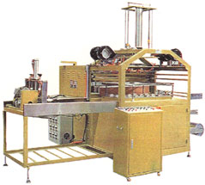
Application：It can be used to mold different type of transparent cover and food
container.
Features:1.This machine has and down molds capable of forming PVC.PET.PP and PS
cover,containers etc.
2.Equipped with automatic plastic roll feeding device for manpower saving.
3.Divided section Heater temperature adjustment controlled by S.S.R can
get the most even,stable and ideal temperature.
4.Equipped with fan and water cooling systems.
適用：成型各種透明罩、食品容器等。
優點：1.本機有上下模裝置，可成型不同深度的PVC、PET、PS、PP等透明罩、容器。
2.本機有自動拉塑膠裝置，免用人工，可節省人力。
3.本機電熱採用分組微調，確保溫度均勻。
4.本機冷卻系統採用自動風冷、水冷設備。

Power電源 | 3P220/415V 50/60HZ
Forming Area(mm)成型面積 | 570×1,000
(Round/min)Forming Efficiency成型能力 | 2-4
Heater電熱器 | 24.2KW
Vacuum Pump真空幫浦 | 5HP
Mechanical Dimensions(L×W×H)(mm) 機械尺寸 | 3,200×2,150×2,600
Case Dimensions(L×W×H)(mm) 裝箱尺寸 | 3,400×2,300×2,090
毛重G.W. 淨重N.W. | 3,500Kgs. 3,000Kgs.

HYDRIALIC TYPE HIGH FREQUENCY WELDING & CUTTING MACHINE油壓式高週波熔接與裁斷機MACHINE

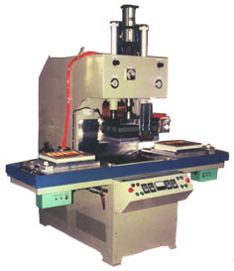
Application：For PVC and PVC toothbrush packing or PVC and Paper toothbrush packing
適用：PVC與PVC材料或PVC與紙卡材料之牙刷盒包裝。
Features:The machine is designed for simultaneous welding and cutting 6 brushes
when processed
特點：此機設計，可在同一次加工中，同時完成6支牙刷高週波熔接及裁斷作業。

Power電源 | 3P220/415V 50/60HZ
Input Power電源入力 | 25KVA
H.F.Out-put Power高週出力 | 15KW
Operating Frequency振盪週率 | 27.12MHZ
Packing Area包裝面積 | 350x450m/m
Packing Capacity包裝能力 | 3~4time/min
Mechanical Dimensions(L×W×H)(mm) 機械尺寸 | 2100×1950×2000
Case Dimensions(L×W×H)(mm) 裝箱尺寸 | 2150×1000×2170×1 2300×900×700×1
N.W. 淨重 | 1050Kgs
G.W. 毛重 | 1200Kgs

