OWN'S Automatic Toothbrush Manufacturing Machines
牙刷專業機械整廠設備-包裝機具


Roller Cutting Machine滾輪式裁斷機

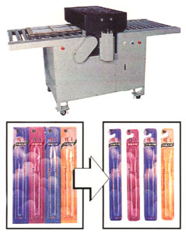
FEATURES:
(1)Cutted by rolling system,that ensures the long-life of cutting knife,
safety & economy.
(2)It can cut several molds for one time and easy to operate.
(3)Applicable for cutting the paper box,plastic blister card & skin
packaging products.
特點：
(1)利用滾輪方式裁剪，且可確保裁刀耐久使用，安全又經濟。
(2)一次可裁切多模，速度快，操作容易。
(3)用途廣，適用於紙盒，塑膠，泡殼及密著成品的裁剪。
規格SPECIFICATIONS:
Power電源 | 3Ø,220V
Packing Capacity包裝能力 | 5Time/Min.
Packing Area包裝面積 | 600×1000m/m
Machine Size機械尺寸 (L×W×H) | 1250×800×900m/m

