OWN'S Automatic Toothbrush Manufacturing Machines
牙刷專業機械整廠設備-包裝機具


HIGH FREQUENCY WAVE PLASTIC WELDING MACHINE高週波塑膠溶接機
Power  電源 | 3P 220/415V 50/60HZ
Air Pressure  空壓源 | 3HP
Max. Power Requlrement  最大入力 | 15KVA
Max. Output  最大出力 | 8KW
Operating Frequency  振盪週率 | 27.12MHZ
Packing Capacity  包裝能力 | 3-4Time/Min
Packing Area  包裝面積 | 350×450 m/m
Machine Size (LxWxH)m/m  機械尺寸(長×寬×高)m/m | 2600×1700×1900
Case Size (LxWxH)m/m  裝箱尺寸(長×寬×高)m/m | 1900×1000×2100×1 2800×800×500×1
N.W. 淨重  G.W. 毛重 | 850KGS  1000KGS

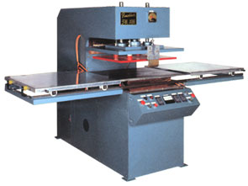
Application：For PVC and PVC toothbrush packing.
Features:The machine is designed for simultaneous welding and breaking 6 PVC and PVC toothbrush when processed or welding PVC and Paper toothbrush packing.
適用：PVC與PVC材料之牙刷盒包裝。
特點：此機設計，可在同一次加工中，同時完成6支
PVC與PVC牙刷盒，高週波熔斷作業。或PVC
與紙卡牙刷盒的熔合作業。

ROTARY BLISTER PACKING MACHINE圓盤式泡殼包裝機

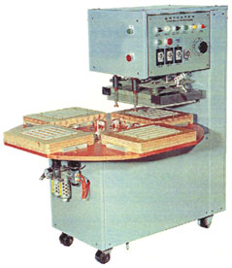
FEATURES:
(1)The action of mold plate is quick and stable in brake or location,no any vibration
that ensures the machine and circuit safe.
(2)After heating,sealing blister and printed paper card are perfectly sealed.
(3)Automatic production,simple operation,save power and time
特點：(1)模子剎車定位動作快速穩定，不產生振動，確保機體與電路的安全。
(2)將泡殼與印刷精美的吊卡式紙板經加熱後貼合。
(3)自動送料、封口。操作簡易，省電省時。.
SPECIFICATIONS規格:
Heater電熱 | 3Kw
Power電源 | 220V,Single Phase
Packing Capacity包裝能力 | 5~10Time/Min.
Packing Area包裝面積 | 400×300m/m
Machine Size機械尺寸 (L×W×H) | 1200×1100×1250m/m

