OWN’S-10

HANDLE MOULD模具
Features
The mould is made under the advanced CMC production
system, by which the toothbrush holes will be quite accu-
rate & precise during tufting.
特色
模具是由先進的CNC機械所製造完成的．具有絕對的精
準度，可確保刷孔在植毛作業中的準確性。
Specifications/規格說明
Material材質…………………………Sweden Assab Stee718
(for the main part)瑞典高密度鏡面鋼718(主要部份)
Cavity穴數……………………Eight or Sixteen 8穴或16穴
Dimention模具尺寸……………………………50×22×28cm
Packing dimention木箱尺寸..………….......…..60×35×32cm
N.W.模具淨重............................…………….…............180kgs
G.W.裝箱毛重.........................………………................190kgs

FLAT BRASS WIRE 扁黃銅線
Specifications/規格說明
Thickness厚度……………………….…………0.23~0.25mm
Width寬度……………………………….………..1.1~1.3mm
Packing dimention(1wooden case for 100kgs)
木箱尺寸(1箱裝100公斤)……………………..55×40×30cm
N.W.扁黃銅線淨重……………………………………100kgs
G.W.扁黃銅線毛重…………………………………….110kgs
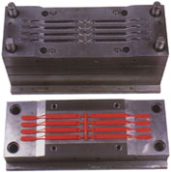

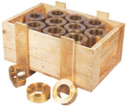

OWN’S-40

MATERIAL BRISTLE BLADE
半自動原料毛切毛機
Features
▼ Both knife & blade inside are made of special steel under the heating treatment.
▼ Cutting edge with the grind-resistance is quite hard &sharp.
特色
▼刀片與刀座採用特殊鋼材所製造，並經過真空熱處理的手續完成硬化作業。
▼特殊堅硬銳利的抗磨刀鋒設計。
Specifications/規格說明
Capacity產量……………………………………………………….…..60kgs/hr.小時
Dimention機械尺寸……………………………….……………..…..130×55×105cm
Packing dimention裝箱尺寸.………….…..145×70×70cm (Legs separated)桌腳拆裝
N.W.機械淨重………………………………...………..………………………..40kgs
G.W.裝箱毛重………………………………..…………….…………………..100kgs

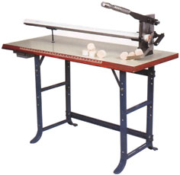

OWN’S-42

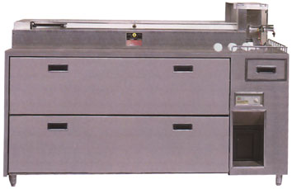

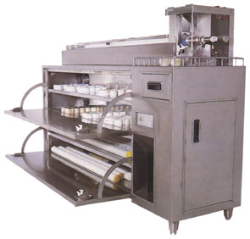
AUTOMATIC MATERIAL BRISTLE CUTTER & WATER SEPARATOR MACHINE
自動原料毛切刀及毛料水份分離機
Features
▼ Elegant appearance made of stainless steel meets abso-
lutely the hygienic production enviroment.
▼ Automatic material bristle feeding, air-pressure cutting,
transparent & safty protection cover and special sharp cutting edge.
▼ 4- cabinets for storing nylon (material bristle), in which the
dehumidifier is installed, which can get rid of the moisture
inside nylon into the water storage tank to stay nylon
perfect under the proper drying reading.
▼ Nylon without moisture can have each tuft of brush insert-
ed averagely on each hole to keep the tufting process
smooth & precise, which is a requisite for making the top
quality toothbrushes.
特色
▼不銹鋼外殼，外觀高貴，永不生銹，合乎衛生的製造環境。
▼自動送料，氣壓截斷，透明安全防護罩，特殊設計銳
利刀鋒。
▼全球首創機內設有四個可存放原料毛的儲藏櫃，在櫃內設有強力的乾燥氣流循環，可將毛料中的水份經由分離機分離至儲水箱中，使毛料保持最佳品質與適當的乾燥度。
▼去除掉水份的尼龍毛，不會產生黏結的現象，可確保在植毛作業中毛料能穩定順暢的被送出，而使每個被植毛的洞孔中，都能保持固定的刷毛數量。此為製造高品質的牙刷所必須具備的條件。
Specifications/規格說明
Capacity產量……………….…………………120kgs/hr.小時Max. length of cutting nylon切出原料毛的最大長度……….
…………………………………………………….…….50mm
Capacity of water storage tank水箱容量……….………..2.4L
Motor馬達………………………………………….…..1/2HP
Voltage電壓…………………..….AC 200-240V 50HZ~60HZ
singlephase單相
Kilowatts消耗電力……………………………………..400W
Air pressure空氣壓力………………..……….…...6-8kgs/cm²
Air fiow空氣用量………………………..…15L/min/(1/2HP)
Dimention機械尺寸………………………….180×50×120cm
Packing dimention木箱尺寸…………………195×65×145cm
N.W.機械淨重………………………………...………..160kgs
G.W.裝箱毛重………………………………....……….265kgs

OWN’S-100

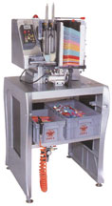
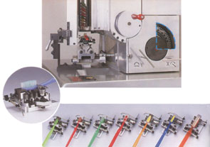
A set of adjustable
cam, clamp & han-
dle chute.
一套可調式萬用齒
輪、夾具與放柄槽。

The universally adjustable clamps for different shapes of toothbrushes.
可調式萬用夾具可適用於各種不同式樣之牙刷。

AUTOMATIC 2-COLOUR TOOTHBRUSH TUFTING MACHINE
自動雙色牙刷植毛機
Features
▼ The components of OWN 'S-100 are 30% fewer than those of the old-mode OWN'S-51, but its productive speed is enhanced up to 4-0 % .
▼ 80 % of OWN'S-100 is made of the special aluminium alloy for the navigational industry under the hardening treatment. Also the appearance through CAD computer drawing design is produced by the combination of the segmental frame of two pieces of alloy and the solid streamlined shape with the different stratum of the concave & convex construction, which will exhibit greatly the perfect visual effect of physique and beauty. And the cover packing design will reduce the noise.
▼ The motion of OWN'S-100 is quite smooth & accurate bec-
ause of the new-fashioned X & Y slide rest having the precise shaft bearing of the linear motion.
▼ Originatively universal clamp, cam & handle chute can suit
the production of any various shapes of toothbrushes out of the characteristic of their repeated adjustment, which will save much time & capital for the new clamp, cam & handle chute making to match each shape's change.
▼ Latest-designed protective installation to keep needles from bumping, which will make brush tufted under the fixed setting reading of air pressure. The protective installation will open automatically to stop tufting if air pressure is over the setting reading, which will prevent needles from breaking & cracking.
▼ During tufting, some special situations, the mechanical break-
down or the insufficient suply of nylon, handles & flat brass wire, will be informed through the indicating light & the alarm sound working.
▼ The machine itself has no the computer installation & PC co-
ntroller, so there is no any trouble in maintenance & repair.
▼ The latest-created mode, OWN'S-lOOC, specializes in 3colo-
ur toothbrush making.
特色
▼ OWN'S-100較舊型OWN'S-51全機零件減少30%，但生產速度卻提高40%。
▼全機80%採用航大鋁合金材料一體成型，並經由硬化處理，質地堅韌輕盈。而機台結構與外觀造形，是經由電腦CAD設計，將兩片鋁合金之圓弧外型框面結合，再由層次不同的凹凸面構成立體流線造型，充份表現出力與美的視覺感受。且因有外殼包覆，故降低機械噪音。
▼新型X、Y滑檯使用高精密的直線運動軸承，以達順暢精確的活動狀態。
▼獨創的萬用刷頭夾具、萬用齒輪及萬用放柄槽，皆可經由重覆調整使用於各種不同款式的牙刷製作。無需如傳統機型，每一式樣均需訂製一套齒輪與刷頭夾具來配合，而浪費很多的時間與金錢。
▼新設計的撞針保護裝置，能使植毛針在設定的壓力內進行植毛，如超過壓力時，保護裝置會彈開自動停止植毛，以防止植毛針斷裂，此將徹底解決長久以來各式植毛機所擁有的最大缺點。
▼遇到故障或需添加原料毛、刷柄及扁黃銅線時，皆有警示燈及警示聲告之，可快速的將其問題解決，繼續進行植毛作業。
▼全機無電腦或PC控制器，因此沒有維修上的困擾。
▼ OWN'S-100C是專為製造新型三色牙刷所提供的最新
機型。
Specifications/規格說明
Capacity產能…T/brush holes tufted/1~66 holes 植毛孔數/1至66孔
Output產量…………250-290 tufts/per min 250束-290束/每分鐘
Shape式樣..............Any various types of irregular arrangement of T/
brush holes各種不規則的刷孔排列式樣
Motor馬達………………………………………………………1/6HP
Voltage電壓………….…220V-240V 50HZ~60HZ single phase單相
Kilowatts消耗電力……………………………………………..220W
Air pressure空氣壓力…………….……………………….5-7kgs/cm²
Air fiow空氣用量………………………………3L/min/10pcs(1/8HP)
Dimention機械尺寸……………………………………70×70×150cm
Packing dimention木箱尺寸……..……………………85×85×165cm
N.W.機械淨重………………………………………………….110kgs
G.W.裝箱淨重………………………………………………….195kgs

OWN’S-160

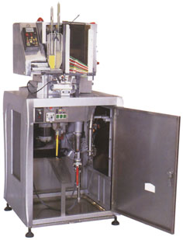
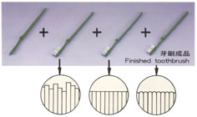
=

AUTOMATIC 2-COLOUR
TOOTHBRUSH TUFTING TRIMMING & END-ROUNDING MACHINE
全自動雙色牙刷、植毛 、修剪 、毛端磨圓製造機

▼ A complete rapid production.
▼ Quality testing straight away.
▼ NO-waiting operation of semi-products supplying.
▼ Big reduction of defective products.
▼實行一貫化快速生產
▼可立即品檢
▼完全無待料空間作業
- 大幅降低成品不良率

Features
- The machine is the first one to be exhibited in Asia, which incorporated tufting, trimming and end-rounding into one entity, by which the toothbrush tufting, trimming & end-rounding will be finalized simultane-
ously by the fully auto-matic operation. So 50 % of manpower will be saved.
▼ The floor square required will be smaller because of the fact that two machines (OWN'S-IOO+OWN'3-60) are incorporated into one entity.
- Trimming & end-rounding facilities are installed
privately in the seal-cabinet located in the lower part of the machine, in which there is a special container for collecting nylon crumbs which will stay clean around the machine.
▼ The machine has two parts, upper & lower, the upper part is fully same with OWN'S-100 just for tufting. (It is optional for 2 colour or 3 colour.) The lower part is for trimming & end-rounding. [It is optional for flat type (just like OWN'S-60) or special type-waved, toothed or segmental types (just like OWN'S-61)].
- One single creative diamond-polishing wheel replaces 8 ones with the different size, which have the brush rounded much more better than before.
- Compared with the European machines with the same
mode, the price of OWN'S-160 is quite low.

特色
▼本機為亞洲第一台結合牙刷植毛、剪毛、毛端磨圓三機為一體，並實施全自動化作業的機型。在作業中無須人力介入，故可將原來的兩個操作工人減少至一人，可省掉約50%的人力。
▼因將修剪毛端磨圓機置於OWN'S-100機台內，故可縮小機械佔地面積，節省廠房用地。
▼修剪機與毛端磨圓機均藏於密閉之機體內，而機內並有毛屑收容器，可將毛屑收集於內，以確保機械周圍之清潔。
▼本機分為桌上與桌底兩部份，桌面上植毛的部份與OWN'S-100完全相同，有雙色與三色C型以供選擇。而桌底機體內為修剪與毛端磨圓處理的部份。有修剪平型，如OWN'S-60與其他式樣像波浪形、弧形、齒型等，如OWN'S-61以供選擇。
▼首創一個特殊功能的鑽石研磨輪代替八個粗細不同的鑽石研磨輪，研磨效果將更加細緻完美。與歐洲同機型相較，價格實屬較低。
Specifications/規格說明
Capacity產能……..T/brush holes tufted/1~66 holes 植毛孔數/1至66孔
Output產量………………250-290 tufts/per min 250束-290束/每分鐘
Shape式樣…………………………………………….Any various types of irregular arrangement of T/brush holes
各種不規則的刷孔排列式樣
Motor馬達………………………………1/10HP×1，1/6HP×1，1/2HP×2
Voltage電壓……………………………………….220V single phase單相
Kilowatts消耗電力………………………………………………….1100W
Air pressure空氣壓力………………………………………….5-7kgs/cm²
Air fiow空氣用量………………………………….15L/min/10pcs(1/2HP)
Dimention機械尺寸…………………………………………70×70×150cm
Packing dimention木箱尺寸………………………………85×85×165cm
N.W.機械淨重……………………………………………………….200kgs
G.W.裝箱淨重……………………………………………………….285kgs

OWN’S -60 (FLAT & STRAIGHT SHAPE 平形) -61(WAVED, TOOTHED OR SEGMENTAL SHAPES, ETC.波浪形、齒形或弧形等特殊造型)

AUTOMATIC BRISTLE TRIMMING & END-ROUNDING MACHINE
自動牙刷修剪毛端磨圓機
Features
▼ 30 universally adjustable clamps, each one of which is
suitable for any various types of toothbrush heads.
▼ 8 latest-designed diamond-polishing wheels can trim &
round the end of brush into the half-ball shape with the smooth surface.
▼ The blade inside is made of special steel with the strong hardness & endurance. The sharp cutting edge can have irregular brushes cut neatly.
▼ The appearance with the stainless steel not simply meets the hygienic standard of producing enviroment and also decrease the surface damage from outside friction & bump and keep perfect.
特色
▼ 30個刷柄夾具，每一個夾具經由調整可夾持不同式樣大小的刷柄。
▼機內採用最新設計的8個鑽石研磨輪，能快速的將修剪後的刷毛尖端，研磨成光滑的半球形狀，藉此，在刷牙時會感到十分舒暢。
▼此機內部刀座皆由特殊金屬鋼材所製成，十分堅硬抗耐，而其銳利的刀鋒，能快速精準的將刷毛表面修剪整齊。
▼不銹鋼材質的外型，不但增加外觀的美感，同時也合乎衛生的製造環境，而且也可消除烤漆外型所易造成的油漆擦痕及剝落等現象。
Specifications/規格說明
Capacity產量……………………….……..3600pcs/hr.小時
Max. length of handle刷柄最大長度………………210mm
Max. width of head刷頭最大寬度…………………..14mm
Max. thickness of head刷頭最大厚度………………3-7mm
Length of brush刷毛長度………………………….5-20mm
Number of adjustable clamp可調夾具數量………….30pcs
Motor馬達…………………………….3/4HP×2，1/8HP×1
Voltage電壓……………………….220V single phase單相
Kilowatts消耗電力……….…………………………1200W
Dimention機械尺寸………………………..100×45×100cm
Packing dimention木箱尺寸……………..115×60×120cm
N.W.機械淨重……………………………………….165kgs
G.W.裝箱淨重……………………………………….235kgs
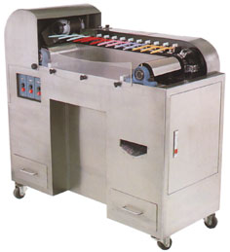

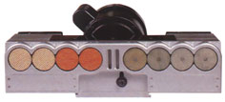

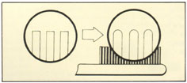

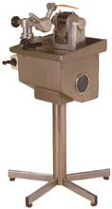
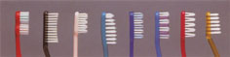
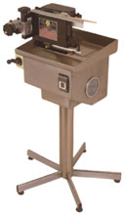
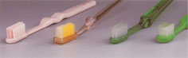

Features
▼ The machine specializes in having brush trimmed into concave &. convex shapes with any kind of long-short shank.
▼ The brush cutting operation can be done at one time. (The steps are to trim brush inside first and then trim brush outside), which will save the trouble for 4 workers operating
▼ The brush trimming is quite stable & precise because of the air-pressure installation for the speed adjustment.
特色
▼本機專為較特殊的縱向刷毛修剪所設計，可將刷毛修剪成凹凸形的長短刷毛式樣。
▼所有修剪動作，皆可一次完成，不須經由4個步驟完成，即先修剪內部刷毛，再剪外部刷毛；此將省去3個人力操作麻煩。(其他式樣可依顧客指定生產)
▼條剪時，有專為速度調整的空壓裝置，因此，在修毛時速度非常穩定，只須人工裝填刷柄，其他機械作業將完全自動執行。
Specifications/規格說明
Capacity產量………………………………………1500pcs/hr.小時
Air pressure使用空壓……………………………………5-7kg/cm²
Motor馬達……………………………………………………1/3HP
Voltage電壓……………………………….220V single phase單相
Kilowatts消耗電力…………………………………………..300W
Dimention機械尺寸……………………………….60×60×100cm
Packing dimention木箱尺寸………………………73×73×120cm
N.W.機械淨重………………………………………………...45kgs
G.W.裝箱淨重……………………………………………….100kgs

Features
▼ Stainless steel appearance, seal-up blade design, which meet the hygienic production enviroment.
▼ During the manual trimming, there is no need to hold tightly because of the handle automatic fixing installation.
▼ The wear-resistant blade under special treatment can have bristle trimmed regularly & neatly.
特色
▼不銹鋼外殼與密封的刀座造型設計，合乎衛生的製造環境。
▼刷柄自動固定裝置，進行剪毛作業時，無須夾緊握柄，無經驗者也能輕易操作。
▼經由特別處理過的耐磨刀具，可修剪出整齊的刷毛。
Specifications/規格說明
Capacity產量………………………………..1200-1800pcs/hr.小時
Thickness of head刷頭厚度…………………………………3-7mm
Max. width of head刷頭最大寬度…………………………..14mm
Motor馬達……………………………………………………1/3HP
Voltage電壓……………………………….220V single phase單相
Kilowatts消耗電力…………………………………………..250W
Dimention機械尺寸…………………………………60×60×100cm
Packing dimention木箱尺寸………………………73×73×120cm
N.W.機械淨重………………………………………………...45kgs
G.W.裝箱淨重…………………………………………….100kgs
OWN’S-70
(FLAT & STRAIGHT SHAPE 平形)
OWN’S-71
(WAVED, TOOTHED OR SEGMENT-
AL SHAPES, ETC.波浪形、齒形或弧形等特殊造型)
SEMI-AUTO BRISTLE TRIMMING MACHINE半自動剪毛機
OWN’S-75
AUTOMATIC AIR PRESSURING STRAIGHT CUTTING MACHINE
自動空壓直行剪毛機

