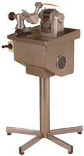
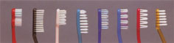
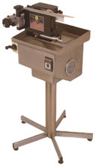
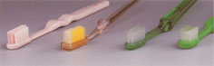

Features
▼ The machine specializes in having brush trimmed into concave &. convex shapes with any kind of long-short shank.
▼ The brush cutting operation can be done at one time. (The steps are to trim brush inside first and then trim brush outside), which will save the trouble for 4 workers operating
▼ The brush trimming is quite stable & precise because of the air-pressure installation for the speed adjustment.
特色
▼本機專為較特殊的縱向刷毛修剪所設計，可將刷毛修剪成凹凸形的長短刷毛式樣。
▼所有修剪動作，皆可一次完成，不須經由4個步驟完成，即先修剪內部刷毛，再剪外部刷毛；此將省去3個人力操作麻煩。(其他式樣可依顧客指定生產)
▼條剪時，有專為速度調整的空壓裝置，因此，在修毛時速度非常穩定，只須人工裝填刷柄，其他機械作業將完全自動執行。
Specifications/規格說明
Capacity產量………………………………………1500pcs/hr.小時
Air pressure使用空壓……………………………………5-7kg/cm²
Motor馬達……………………………………………………1/3HP
Voltage電壓……………………………….220V single phase單相
Kilowatts消耗電力…………………………………………..300W
Dimention機械尺寸……………………………….60×60×100cm
Packing dimention木箱尺寸………………………73×73×120cm
N.W.機械淨重………………………………………………...45kgs
G.W.裝箱淨重……………………………………………….100kgs

Features
▼ Stainless steel appearance, seal-up blade design, which meet the hygienic production enviroment.
▼ During the manual trimming, there is no need to hold tightly because of the handle automatic fixing installation.
▼ The wear-resistant blade under special treatment can have bristle trimmed regularly & neatly.
特色
▼不銹鋼外殼與密封的刀座造型設計，合乎衛生的製造環境。
▼刷柄自動固定裝置，進行剪毛作業時，無須夾緊握柄，無經驗者也能輕易操作。
▼經由特別處理過的耐磨刀具，可修剪出整齊的刷毛。
Specifications/規格說明
Capacity產量………………………………..1200-1800pcs/hr.小時
Thickness of head刷頭厚度…………………………………3-7mm
Max. width of head刷頭最大寬度…………………………..14mm
Motor馬達……………………………………………………1/3HP
Voltage電壓……………………………….220V single phase單相
Kilowatts消耗電力…………………………………………..250W
Dimention機械尺寸…………………………………60×60×100cm
Packing dimention木箱尺寸………………………73×73×120cm
N.W.機械淨重………………………………………………...45kgs
G.W.裝箱淨重…………………………………………….100kgs
OWN’S-70
(FLAT & STRAIGHT SHAPE 平形)
OWN’S-71
(WAVED, TOOTHED OR SEGMENT-
AL SHAPES, ETC.波浪形、齒形或弧形等特殊造型)
SEMI-AUTO BRISTLE TRIMMING MACHINE半自動剪毛機
OWN’S-75
AUTOMATIC AIR PRESSURING STRAIGHT CUTTING MACHINE
自動空壓直行剪毛機

