OWN’S-42

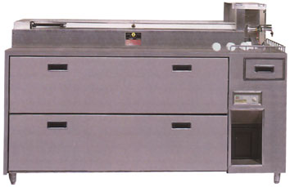

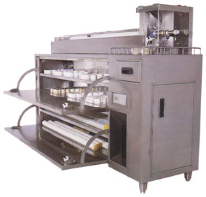
AUTOMATIC MATERIAL BRISTLE CUTTER & WATER SEPARATOR MACHINE
自動原料毛切刀及毛料水份分離機
Features
▼ Elegant appearance made of stainless steel meets abso-
lutely the hygienic production enviroment.
▼ Automatic material bristle feeding, air-pressure cutting,
transparent & safty protection cover and special sharp cutting edge.
▼ 4- cabinets for storing nylon (material bristle), in which the
dehumidifier is installed, which can get rid of the moisture
inside nylon into the water storage tank to stay nylon
perfect under the proper drying reading.
▼ Nylon without moisture can have each tuft of brush insert-
ed averagely on each hole to keep the tufting process
smooth & precise, which is a requisite for making the top
quality toothbrushes.
特色
▼不銹鋼外殼，外觀高貴，永不生銹，合乎衛生的製造環境。
▼自動送料，氣壓截斷，透明安全防護罩，特殊設計銳
利刀鋒。
▼全球首創機內設有四個可存放原料毛的儲藏櫃，在櫃內設有強力的乾燥氣流循環，可將毛料中的水份經由分離機分離至儲水箱中，使毛料保持最佳品質與適當的乾燥度。
▼去除掉水份的尼龍毛，不會產生黏結的現象，可確保在植毛作業中毛料能穩定順暢的被送出，而使每個被植毛的洞孔中，都能保持固定的刷毛數量。此為製造高品質的牙刷所必須具備的條件。
Specifications/規格說明
Capacity產量……………….…………………120kgs/hr.小時Max. length of cutting nylon切出原料毛的最大長度……….
…………………………………………………….…….50mm
Capacity of water storage tank水箱容量……….………..2.4L
Motor馬達………………………………………….…..1/2HP
Voltage電壓…………………..….AC 200-240V 50HZ~60HZ
singlephase單相
Kilowatts消耗電力……………………………………..400W
Air pressure空氣壓力………………..……….…...6-8kgs/cm²
Air fiow空氣用量………………………..…15L/min/(1/2HP)
Dimention機械尺寸………………………….180×50×120cm
Packing dimention木箱尺寸…………………195×65×145cm
N.W.機械淨重………………………………...………..160kgs
G.W.裝箱毛重………………………………....……….265kgs

