OWN’S-10

HANDLE MOULD模具
Features
The mould is made under the advanced CMC production
system, by which the toothbrush holes will be quite accu-
rate & precise during tufting.
特色
模具是由先進的CNC機械所製造完成的．具有絕對的精
準度，可確保刷孔在植毛作業中的準確性。
Specifications/規格說明
Material材質…………………………Sweden Assab Stee718
(for the main part)瑞典高密度鏡面鋼718(主要部份)
Cavity穴數……………………Eight or Sixteen 8穴或16穴
Dimention模具尺寸……………………………50×22×28cm
Packing dimention木箱尺寸..………….......…..60×35×32cm
N.W.模具淨重............................…………….…............180kgs
G.W.裝箱毛重.........................………………................190kgs

FLAT BRASS WIRE 扁黃銅線
Specifications/規格說明
Thickness厚度……………………….…………0.23~0.25mm
Width寬度……………………………….………..1.1~1.3mm
Packing dimention(1wooden case for 100kgs)
木箱尺寸(1箱裝100公斤)……………………..55×40×30cm
N.W.扁黃銅線淨重……………………………………100kgs
G.W.扁黃銅線毛重…………………………………….110kgs
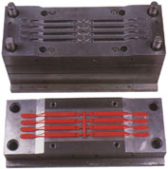

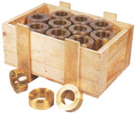

OWN’S-40

MATERIAL BRISTLE BLADE
半自動原料毛切毛機
Features
▼ Both knife & blade inside are made of special steel under the heating treatment.
▼ Cutting edge with the grind-resistance is quite hard &sharp.
特色
▼刀片與刀座採用特殊鋼材所製造，並經過真空熱處理的手續完成硬化作業。
▼特殊堅硬銳利的抗磨刀鋒設計。
Specifications/規格說明
Capacity產量……………………………………………………….…..60kgs/hr.小時
Dimention機械尺寸……………………………….……………..…..130×55×105cm
Packing dimention裝箱尺寸.………….…..145×70×70cm (Legs separated)桌腳拆裝
N.W.機械淨重………………………………...………..………………………..40kgs
G.W.裝箱毛重………………………………..…………….…………………..100kgs

